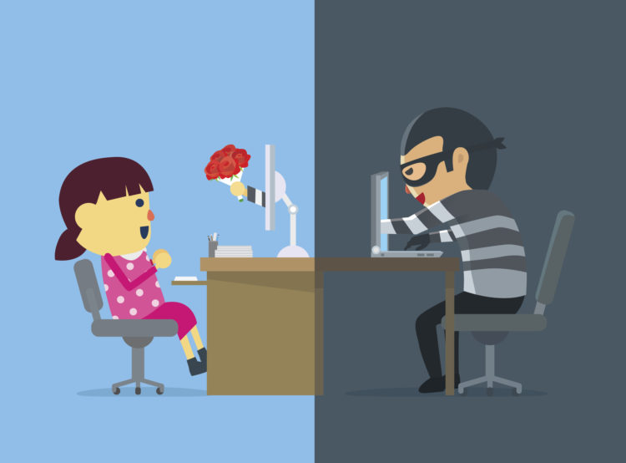
Meeting new friends and romantic partners
The Internet is a great place to meet people, whether it’s someone who shares your passion for an activity or cause, or a potential romantic partner. There are many online groups and forums where people with similar interests meet and that sometimes leads to getting together for all sorts of activities ranging from walks and bike rides to meetings to discuss issues or political candidates.
Online dating is also very popular with seniors and many have met great people via online dating sites, leading to friendships, romantic relationships and sometimes marriage.
Stay safe tips
- If you do arrange an in-person meeting with someone you meet online, make sure the first meeting is in a public place, like a restaurant, and bring a friend or at least let others know where you’re going to be.
- Bring along your cell phone and have a friend call you during the meeting just to make sure all is going well.
Be aware of online dating scams.
- There are cases where seniors, as well as younger people, have been scammed into parting with their money and left heartbroken.
- With anyone you meet online, there is always the possibility they may not be who they claim to be.
Watch for red flags.
- They can include a person who claims or looks to be a lot younger than you or who sends you a picture that looks as if it came from a fashion site. The Police warn people to be careful about anyone who claims to be from the UK who is traveling or working overseas and suggests that you only deal with reputable dating sites.
- Other red flags include the person pressuring you to leave the dating site to communicate via email or text messaging or someone who professes instant feelings of love.
- Be suspicious of anyone who is never actually available for a face-to-face meeting.
- Look for abnormalities in the way a person writes and the type of grammar and words they use. It may not mean anything but it could be a sign that they are in a foreign country and may have no intention of actually meeting you.
Don’t send money.
- Be especially suspicious and don’t send money if the person asks for money, perhaps to get on a plane to come meet you or to help them deal with a personal or family crisis.

